Student Learning Outcomes / Administrative Unit Outcomes
Committee Meeting
Tuesday, September 19, 2017
CTC-131
Next Meeting: Thursday, October 17, 02:00 PM, CTC-131
Review from Last Meeting: | - Training/Help solution this week: Zoom Meeting  - Waiting on meeting with GoverNET: Assessment Reports, modificatoin of forms  - Naming Conventions this week
Training / Help Solution | I met with our Zoom Video Conferencing Rep last week, and he went through various meeting and help scenarios using the software available through ConferZoom.org.
https://support.zoom.us/hc/en-us/articles/206618765-Zoom-Video-Tutorials
Add Semester Year to Naming Conventions: | See attached:
Review of Objectives, Assessments, and Outcomes Relationships: | See attached:
Questions?

ConferZoom Overview
Personal Meeting: people connect directly with you. can be set always on. automatically switches between desktop/mobile.
Scheduled Meeting: creates a unique group that people can join controlled by the host. Can be set to recurring based on calendar.
Waiting Room: individual/group meeting with do not disturb. Others are put in a "waiting room" until they can join (meeting over or invited in).
Could be used by Admissions, Financial Aid, Counseling, Virtual Orientation.
Compatible with YouTube Live
Can create Zoom Rooms; classrooms and conference rooms pre-configured with video, display, audio, that you just walk in and start a meeting (Personal Meeting using a room). All controls use wireless.
All meetings and rooms scheduled through calendar programs or the Web.
https://cccconfer.zoom.us/my/rwatkins
CurricUNET Assessment Naming Conventions
- Individual Instructor SLO:
SUBJECT COURSE SECTION SLO# YEARSEMESTER [AUTHOR] optional
CIS-135-2543 SLO1 17SP rwatkins
- Aggregate of Instructor SLOs:
SUBJECT COURSE SLO# YEARSEMESTER [AUTHOR] optional
CIS-135 SLO1 17SP rwatkins
- Aggregate of SLOs in a Course:
SUBJECT COURSE All SLOs YEARSEMESTER [AUTHOR] optional
CIS-135 All SLOs 17SP rwatkins
- Aggregate of Mapped SLOs to a PLO:
PROGRAM NAME SLO# YEARSEMESTER [AUTHOR] optional
Computer Programming PLO1 17SP rwatkins
- Aggregate of All PLOs in a Program:
PROGRAM NAME All PLOs YEARSEMESTER [AUTHOR] optional
Computer Programming All PLOs 17SP rwatkins
- Aggregate of Mapped SLOs to an ILO:
Courses to ILO# YEARSEMESTER [AUTHOR] optional
Courses to ILO1 17SP rwatkins
- Aggregate of Mapped PLOs to an ILO:
Programs to ILO# YEARSEMESTER [AUTHOR] optional
Programs to ILO 17SP rwatkins
- Non-Instructional Unit Outcome
UNIT NAME OUTCOME# YEARSEMESTER [AUTHOR] optional
Business Services AUO1 SP17 ndimitri
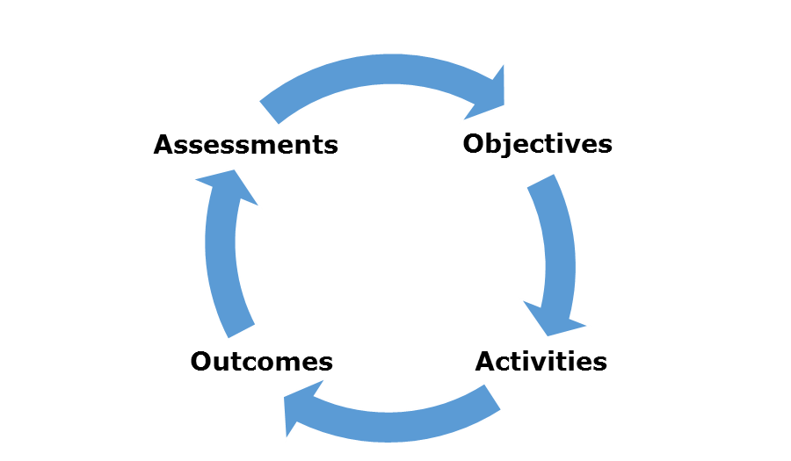
The Educational Process
Learning: Unless by accident, learning occurs in four stages: objectives, activities, outcomes, and assessments. This happens anywhere: on a personal basis, in a business, in marketing, and, most importantly, in education.
Objectives: Objectives are goals you want to get out of the process. They are dreams.
Activities: Activities are the individual steps required to achieve each objective. These require both input (direction) and output (results).
Outcomes: Outcomes are the measures of completion or competence of each activity. They are grades.
Assessments: Assessments are the comparison of the results of the outcomes to the original objectives. You can complete every activity but not obtain your objective. In this instance, either the objectives need to be changed or the activities.
This is the purpose of Accreditation, Self-Evaluation, Department Review, Program Review, Course Review, and Personnel Review.
CIC Manual Course Assessment Criteria
3. Student Assessment: Check the methods that will be used.
- TITLE 5 requires that certain methods of evaluation must be used to assess student outcomes.
- Only DEGREE-CREDIT and NON-DEGREE CREDIT courses must assign grades. Fifty percent of the grade must be based on critical thinking, problem-solving and/or skills demonstration.
- A COLLEGE-LEVEL COURSE requires the use of critical thinking, college-level concepts and college-level skills. It must also require essay writing unless that requirement would be inappropriate to the course objectives. If writing is inappropriate, there must be a requirement of problem-solving or skills demonstration. If DEGREE CREDIT, at least ONE of the first three items must be included. If Essay not included, explain.
- NON-CREDIT courses do not need grades, but some assessment method must be described, indicating the methods that will be used to evaluate how well the course objectives are met.
Student assessment: Course must require use of critical thinking, college-level concepts & college-level learning skills. It must also require essay writing unless that requirement would be inappropriate to the course objectives. If writing is inappropriate, there must be a requirement of problem-solving or skills demonstration. If Degree Credit, at least ONE of the first three items must be included. If Essay is not included, explain.
1. Essay
2. Computation Skills
3. Non-computational Problem Solving
4. Skill Demonstration
5. Objective Examinations
6. Other (describe)
9. Student Evaluation: Provide the methods of assessment and the percentage of total grade for each of them.
• DEGREE-CREDIT and NON-DEGREE CREDIT courses must assign grades. TITLE V requires that certain methods of evaluation must be used to assess student outcomes. Fifty percent of the grade must be based on critical thinking, problem-solving and/or skills demonstration.
• NON-CREDIT COURSES must have some method(s) of assessment, but do not need to assign grades. Non-credit courses should indicate the methods that will be used to evaluate how well the course objectives are met.
Examples | Intended Outcome | Assessment Method | Assessment Criteria
1. | Students will improve their ability to communicate in writing. | Writing samples from the start of the semester will be compared with writing samples at the end of the semester. Samples will be evaluated for clarity, vocabulary, organization and grammar using a rubric designed by the department. | At least three-fourths of the students will demonstrate at least a 20 percent increase in all evaluated aspects listed in the rubric.
2. | Students will exhibit expertise in their knowledge of earthquake fault systems and how they relate to plate tectonic processes. | Students will answer embedded questions in midterm and final exams. A scantron scanner will be used to assess the results for each of the relevant questions. | Each question will be answered correctly by 75% of students.
3. | Students will be able to understand an article published in the Wall Street Journal evaluating the state of the economy. | As part of a regularly scheduled exam, students will be asked a series of questions about a WSJ article. A random selection of exams from all sections will be evaluated using a rubric. | Of the randomly selected exams, at least 75 percent of the students will score an average of 3 points on a 5 point rubric

